11.98: a) For constant temperature 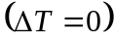,
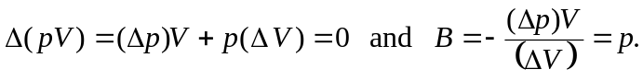
b) In this situation,
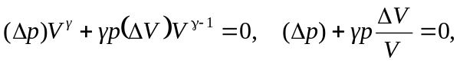
and
